A000-Mask-Afr-Niger-Bura-Head-Double Neckbands-3rd to 11th century CE

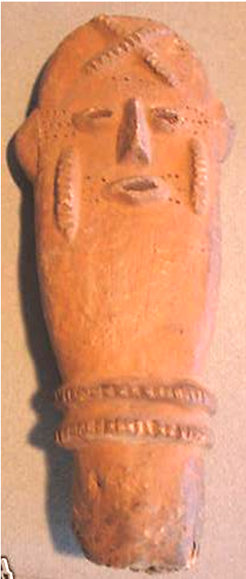

Fig. 1. Mask-Afr-Niger-Bura-Head-Double Neckbands-3rd to 11th century CE

Case No.: 6

**Accession No.**

**Formal Label:** Mask-Afr-Niger-Bura-Head-Double Neckbands-3rd to 11th century CE

**Display Description:**

Niger, Bura Iron Age culture Terracotta head, excellent condition showing fine terracotta appliqué of facial features including scarifications. This terracotta figure possibly of an ancestor depicts a head with an elongated neck and two neck bands. While it has the air of a traditional funeral urn due to its indisputably phallic shape, it evokes the essence of the deceased with a facial expression that is calm and serene. The geometrical keloid tradition of the Bura in this funerary object displays an aesthetic that reveals its anthropomorphic counterparts in the funerary urns, which are abstractions of this face. Note that the sharply incised nose with its narrow d=dimensions is not typical of the physiognomy of this area. Is this an indigenous individual or a person from afar having traveled the long journey across the Sahara as a trader?

Numerous clay objects have come to light from the great Inland Delta Cultures of the Niger River and Benue River confluence. This figure was fired at a relatively low temperature to give it the brownish-red color.

The Bura Iron Age culture (3rd to 11th century CE ) is named for the Bura archaeological site first discovered in the [Tillabéry Region](http://en.wikipedia.org/wiki/Tillabéry_Region), [Tera Department](http://en.wikipedia.org/wiki/Tera_Department), SW [Niger](http://en.wikipedia.org/wiki/Niger), in 1975. Two other associated sites of especial note are Asinda and Sikka in Burkina Faso and Niger respectively. The Bura culture encompasses a wide set of [archeological](http://en.wikipedia.org/wiki/Archeological) sites in the lower [Niger River](http://en.wikipedia.org/wiki/Niger_River) valley bordering SW [Niger](http://en.wikipedia.org/wiki/Niger) and SE [Burkina Faso](http://en.wikipedia.org/wiki/Burkina_Faso). Excavated objects include terracotta heads, vessels and funerary urns, stone heads and iron arrow points.

The terracottas have distinctive raised clay curvilinear motifs of unknown meaning. It is of importance that workers with fire, be they smiths or potters, were considered especially gifted in West African society and so were accorded a prominent place among their peers. They were even considered gifted healers in many instances because they often had knowledge of the herbal remedies for many bodily ailments. Their multifarious knowledge provided their communities with a valued benefit, but it came at a cost: they were also set apart from the general villagers because of their special knowledge and so were also marginalized socially from general village life. Perhaps the keloids on this sculpted head are an indication that the individual was a fire-working artisan, because the crossed keloid pattern on its forehead may indicate the crossed sticks that were used to start the smithy's or potter's fire. Because the bust is terminated at the neck we cannot be sure that it is either male or female.

The Bura culture belongs to a set of archaeological sites in the middle Niger valley in an area 250km long and about 150 km wide. The Bura site consists of many individual [necropoleis](http://en.wikipedia.org/wiki/Necropoleis) with coffins crested by unusually-distinctive [terracotta](http://en.wikipedia.org/wiki/Terra_cotta) [statuettes](http://en.wikipedia.org/wiki/Statuette). The main [necropolis](http://en.wikipedia.org/wiki/Necropolis) itself has a diameter of about one kilometer. Burial mounds, religious altars, and ancient dwellings occur here over a large area. In 1983 a site 25 meters by 20 meters was excavated.

**LC Classification:**

**Date or Time Horizon:**

**Geographical Area:**

**Map:**

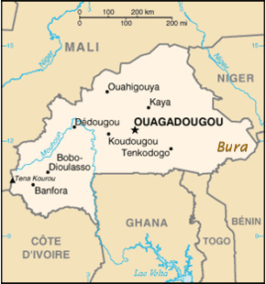

**GPS coordinates:**

**Cultural Affiliation:**

**Media:**

**Dimensions: H** 8 in

**Weight:**

**Condition:**

**Provenance:**

**Discussion:**

**References:**